|  |
| --- |
| Food Violations Report |
| Tomas Heligr-Pyke2810ICT Software TechnologiesSeptember 30, 2019 |

# Abstract

According to this report the most noticeable violation is F044 (# 44. Floors, walls and ceilings: properly built, maintained in good repair and clean) with 102010 unique violations. Only one restaurant over the 2 years has had no violations in one month. The graphs show outliers during 2016/4 and 2017/12 for the Average of all of California (peaking), 2017/12 for lowest total postcode (90025) (peaking), and a large collection of peaks in the third quarter of 2017 for the highest total postcode (90746). Burger King has the least amount of violations in comparison to McDonalds. Comparable peak at 2016/4 between both graphs.

# Introduction

The purpose of this report is to show the final details of the analysis that the provided programs have created based on the food violation data given. The following report is going to explain the findings of this analysis. The following is the Database details, the excel table created of violation counts, and the final graphs created from the initial data. All sections include an analysis.

## Database Structure

The following database is created by running all of the included applications, (below is table schemas):

|  |  |
| --- | --- |
| Inspections (Table) |  |
| Id | INTEGER PRIMARY KEY |
| activity_date | DATE |
| employee_id | CHAR(9) |
| facility_address | VARCHAR |
| facility_city | VARCHAR |
| facility_id | CHAR(9) |
| facility_name | VARCHAR |
| facility_state | CHAR(2) |
| facility_zip | VARCHAR |
| grade | CHAR(1) |
| owner_id | CHAR(9) |
| owner_name | VARCHAR |
| pe_description | VARCHAR |
| program_element_pe | INTEGER |
| program_name | VARCHAR |
| program_status | VARCHAR |
| record_id | CHAR(9) |
| score | INTEGER |
| serial_number | CHAR(9) REFERENCES Violations(serial_number) |
| service_code | INTEGER |
| service_description | VARCHAR |

|  |  |
| --- | --- |
| Violations (Table) |  |
| id | INTEGER PRIMARY KEY |
| points | INTEGER |
| serial_number | CHAR(9) |
| violation_code | CHAR(4) |
| violation_description | VARCHAR |
| violation_status | VARCHAR |

|  |  |
| --- | --- |
| PreviousViolations (Table) |  |
| id | INTEGER PRIMARY KEY |
| facility_name | VARCHAR |
| facility_address | VARCHAR |
| facility_zip | VARCHAR |
| facility_city | VARCHAR |

# **Violation counts**

Below is the table created when running the excel_food.py script with the given data. As seen below we can identify which violations need most attention in California, by seeing how many violations are per violation type. From this data we can see that F044 (# 44. Floors, walls and ceilings: properly built, maintained in good repair and clean) has 102010 unique violations, meaning 102010 restaurants have violated this requirement. It can also be seen that only one restaurant has no health code violations at the time of inspection (See SF15). This shows that the biggest fault is building maintenance, this requires immediate attention. Please note, this is over a close to 2 year period (end 2015 to end 2017), and violations are totalled from all 2 years.

| Code | Description | Count |
| --- | --- | --- |
| CL21 | Public Health Permit/License valid | 1 |
| F001 | # 01a. Demonstration of knowledge | 6874 |
| F002 | # 02. Communicable disease; reporting, restrictions & exclusions | 38 |
| F003 | # 03. No discharge from eyes, nose, and mouth | 36 |
| F004 | # 04. Proper eating, drinking, or tobacco use | 3364 |
| F005 | # 05. Hands clean and properly washed; gloves used properly | 5151 |
| F006 | # 06. Adequate handwashing facilities supplied & accessible | 33952 |
| F007 | # 07. Proper hot and cold holding temperatures | 41105 |
| F008 | # 08. Time as a public health control; procedures & records | 4706 |
| F009 | # 09. Proper cooling methods | 7993 |
| F010 | # 10. Proper cooking time & temperatures | 51 |
| F011 | # 11. Proper reheating procedures for hot holding | 854 |
| F012 | # 12. Returned and reservice food | 28 |
| F013 | # 13. Food in good condition, safe and unadulterated | 5009 |
| F014 | # 14. Food contact surfaces: clean and sanitized | 34441 |
| F015 | # 15. Food obtained from approved source | 622 |
| F016 | # 16. Compliance with shelf stock tags, condition, displayed | 1087 |
| F017 | # 17. Compliance with Gulf Oyster Regulations | 44 |
| F018 | # 18. Compliance with variance, specialized process, & HACCP Plan | 213 |
| F019 | # 19. Consumer advisory provided for raw or undercooked foods | 255 |
| F020 | # 20. Licensed health care facilities/public & private schools; prohibited foods not offered | 1 |
| F021 | # 21b. Water available | 6786 |
| F022 | # 22. Sewage and wastewater properly disposed | 1636 |
| F023 | # 23. No rodents, insects, birds, or animals | 29722 |
| F024 | # 24. Person in charge present and performs duties | 983 |
| F025 | # 25. Personal cleanliness and hair restraints | 11878 |
| F026 | # 26. Approved thawing methods used, frozen food maintained frozen | 7798 |
| F027 | # 27. Food separated and protected | 17866 |
| F028 | # 28. Fruits and vegetables washed as required | 207 |
| F029 | # 29. Toxic substances properly identified, stored, used | 17986 |
| F030 | # 30. Food properly stored; food storage containers identified | 39854 |
| F031 | # 31. Consumer self service facilities properly constructed and maintained | 669 |
| F032 | # 32. Food properly labeled & honestly presented | 6734 |
| F033 | # 33. Nonfood-contact surfaces clean and in good repair | 100080 |
| F034 | # 34. Warewashing facilities: Adequate, maintained, properly use, test strips available | 19208 |
| F035 | # 35. Equipment/Utensils - approved; installed; clean; good repair, capacity | 80010 |
| F036 | # 36. Equipment, utensils and linens: storage and use | 49742 |
| F037 | # 37. Adequate ventilation and lighting; designated areas, use | 48042 |
| F038 | # 38. Thermometers provided and accurate | 11060 |
| F039 | # 39. Wiping cloths: properly used and stored | 35845 |
| F040 | # 40. Plumbing: Plumbing in good repair, proper backflow devices | 50868 |
| F041 | # 41. Garbage and refuse properly disposed; facilities maintained | 4742 |
| F042 | # 42. Toilet facilities: properly constructed, supplied, cleaned | 16153 |
| F043 | # 43. Premises; personal/cleaning items; vermin-proofing | 42943 |
| F044 | # 44. Floors, walls and ceilings: properly built, maintained in good repair and clean | 102010 |
| F045 | # 45. Sleeping quarters | 437 |
| F046 | # 46. Signs posted; last inspection report available | 15735 |
| F047 | # 48. Plan Review required for new or remodel construction | 607 |
| F048 | # 47. Permits Available | 5510 |
| F049 | # 50. Impoundment of unsanitary equipment or food | 5926 |
| F050 | # 51. Permit Suspension | 2950 |
| F051 | # 49. Samples Collected | 40 |
| F052 | # 01b. Food safety certification | 18359 |
| F053 | # 21a. Hot Water Available | 4218 |
| F054 | # 52. Multiple Major Critical Violations / Increased Risk to Public Health | 1214 |
| F055 | # 01a. Demonstration of knowledge | 1515 |
| F056 | # 10. Proper cooking time & temperatures | 12 |
| F057 | # 18. Compliance with variance, specialized process, & HACCP Plan | 43 |
| F058 | # 19. Consumer advisory provided for raw or undercooked foods | 185 |
| MF07 | # 07. Adequate handwashing facilities supplied & accessible | 1 |
| MF42 | # 42. Garbage and refuse properly disposed; facilities maintained | 1 |
| SF15 | No Health Code Violations Observed At The Time Of Inspection | 1 |
| SS33 | Garbage / rubbish receptacles not maintained clean and sanitary | 1 |
| W001 | Proper hot and cold holding temperatures | 9 |
| W002 | Food in good condition, safe and unadultered | 1 |
| W003 | Food storage separated and protected | 6 |
| W004 | Food storage space | 3 |
| W005 | Food elevated | 11 |
| W006 | Food packaging protected | 2 |
| W008 | Rodent | 6 |
| W009 | Cockroaches | 42 |
| W011 | Storage of materials 18 inches above the floor. | 2 |
| W012 | Fly Breeding Material | 3 |
| W014 | Fly Breeding | 5 |
| W016 | Building rodent proof | 3 |
| W017 | Hot and cold water available | 18 |
| W018 | Waste water or sewage properly disposed or not discharged on the ground. | 3 |
| W019 | Plumbing approved and maintained in good repair. | 15 |
| W020 | Wall(s) maintained clean | 9 |
| W021 | Wall(s) maintained in good repair | 6 |
| W022 | Wall(s) constructed of approved material | 1 |
| W023 | Floor maintained clean | 23 |
| W024 | Floor maintained in good repair | 5 |
| W025 | Ceiling maintained clean | 2 |
| W026 | Ceiling maintained in good repair | 3 |
| W027 | Ceiling constructed of smooth, durable, and non-absorbent material | 5 |
| W028 | Toilet in good repair | 3 |
| W029 | Toilet maintained clean / sanitary | 4 |
| W030 | Hand sink in good repair | 1 |
| W031 | Hand sink maintained clean / sanitary | 4 |
| W032 | Toilet room floor / walls / ceiling in good repair | 3 |
| W033 | Toilet room floor / walls / ceiling clean | 2 |
| W034 | Toilet room with toilet paper / soap / towels / trash receptacle | 4 |
| W035 | Toilet room well ventilated | 2 |
| W036 | Toilet room well lighted | 2 |
| W037 | Toilet available | 1 |
| W038 | Hand sink available | 1 |
| W039 | Proper storage or use of hazardous materials | 1 |
| W040 | Compliance with shellfish tag requirements | 2 |
| W041 | Premises maintained clean and sanitary | 6 |
| W042 | Garbage / Rubbish receptacles approved type | 7 |
| W043 | Garbage / Rubbish receptacles maintained in good repair | 3 |
| W044 | Garbage / Rubbish receptacles maintained clean and sanitary | 4 |
| W045 | No unapproved sleeping accomodations | 1 |
| W046 | Live animals | 1 |
| W047 | Thermometer: available, maintained in good repair | 7 |
| W048 | Permits Available | 121 |
| W049 | Food from an approved source | 5 |
| W050 | Food properly labeled | 14 |
| W051 | Walls, Floors, Ceilings: approved, maintained clean and in good repair | 32 |
| W052 | Equipment, Shelving, Cabinets: approved, maintained clean and in good repair | 31 |
| W053 | Permit Suspension | 35 |
| WP13 | # 13. Disease Transmission - Carrier / Lesion / Rash | 1 |
| WP15 | # 15. Tobacco / Eating / Drinking / Habits / Behaviors | 1 |
| WP16 | # 16. Hair Restraints / Outer Garments / Nails / Rings | 1 |
| WP18 | # 18. Personal Hygiene | 1 |
|  | Total Violations | 905886 |

# **Violations over time**

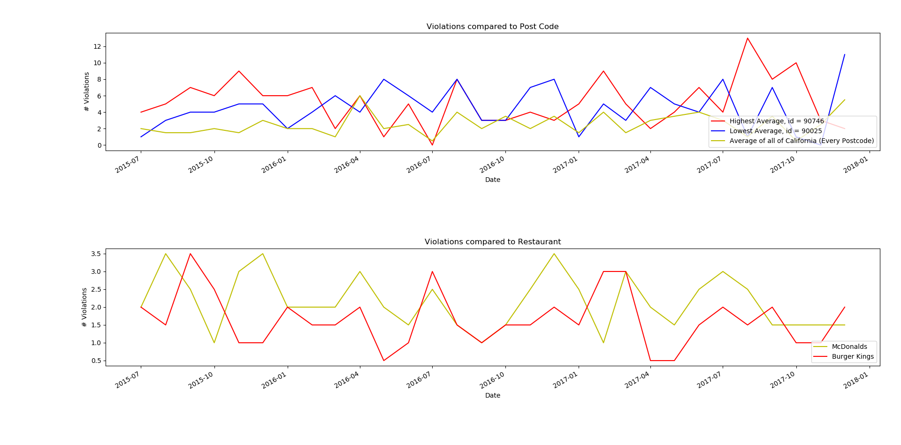Fig 1, graphs created form numpy_food.py script

Fig 2, altered graphs showing the totals of the highest and lowest post code compared to the average of California.

Figure 1 shows the post code with the highest average violation count (over all 2 years, 90746), post code with lowest average violation count (over all 2 years, 90025), as well as the average of all of California (of violation count). The graph shows that most of the time there is around 1 to 4 average violations, there however is some outliers seen, such as 2016/4 having an abnormal monthly average of 6 violations, however the average of that month for the highest is only around a 3, meaning that other postcodes had an abnormal amount of violations during this time. Highest average appears to be erratic, peaking in the third quarter of 2017, most likely causing it to be seen as the highest over the 2 years. The lowest average also has a peak at the very end of 2017, along with the average of all of California. From this graph expected violations, excluding outliers, can be seen to be in the range of 1 to 5 violations per month on average.

The second graph shows McDonalds and Burger King compared by amount of violations per month, Burger King on average has the least amount of violations in comparison to McDonalds. Please note this is all McDonalds in all of California compared to all Burger Kings in all of California.

The peak in 2016/4 is comparable between both graphs, they both show an increase in violations at that time; however this is the only obvious comparison between both graphs.

Further research will be needed in order to find out what was the cause of the outliers, if there was any world events that took place at that time or changes to standards.